9*

*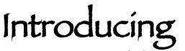****Lynnette Oquendo***

One Year Reflection

A little information about my background: In my Hmong culture, the elderly have a big impact on the growth and development of grandchildren. Decisions are not made without the grandparents’ consent. They are almost always taken care of by the youngest son. Since my parents were away working double shifts at work, my grandparents reared me and my siblings. Just when I had started to appreciate their story time and company, they passed away. As I grew up I forgot how it was to have them around, and it was weird to see others gain affection from their grandparents. After college I moved up to Asheville with some church families and friends.

My friend’s grandmother was living with them and I began to experience the love of a grandparent. Considering that it’s something so significant in our culture, I felt blessed to experience that again. Around the same time that I moved up to Asheville, I began working at the Baptist Retirement Home. Working here has been a blessing, as it has challenged me socially, helped me focus and helped move my set of skills to a new level. As my first full year of working is but moments away, I reflect on how much joy the residents here have brought me. During my time here, I have prayed with the residents, encouraged and received encouragement, and learned stories of old. Working and serving the residents has encouraged me to fight the good fight, all the way to the end.

-Steve Vang

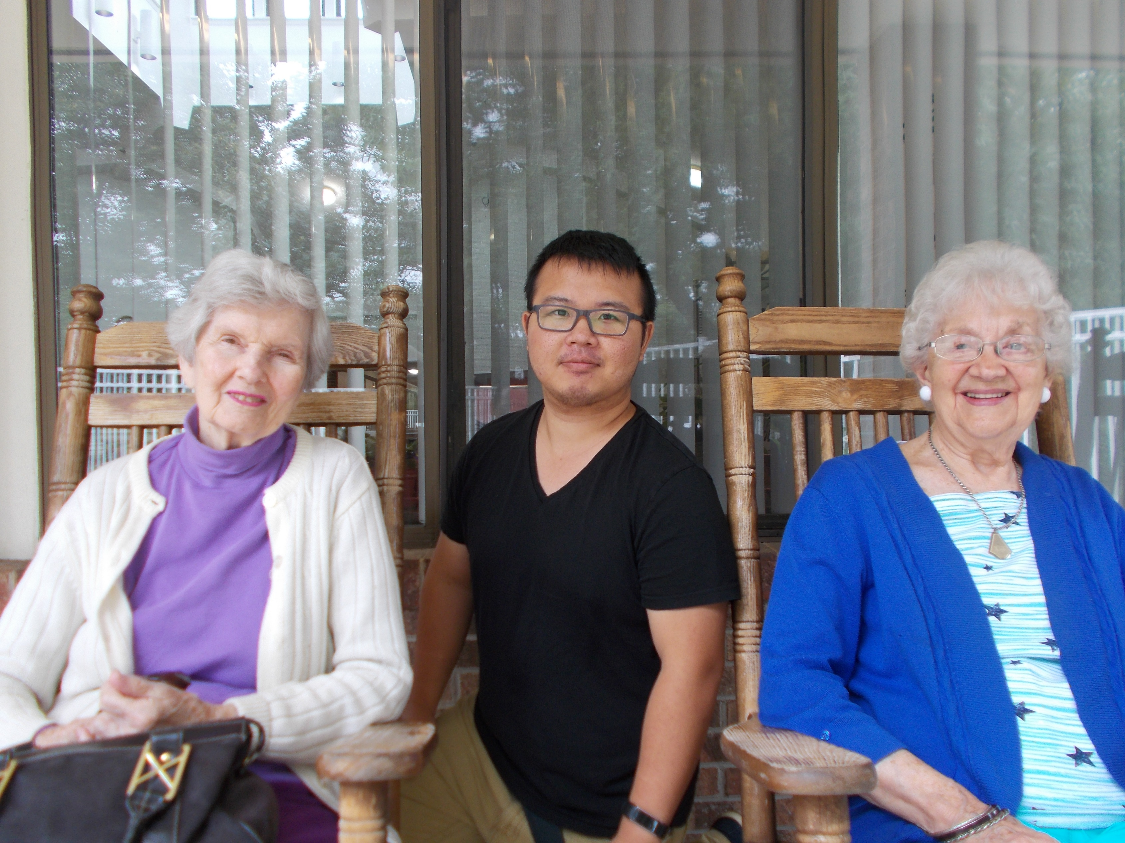

The first question I am always asked is “How do you pronounce your last name?” The answer is O-kwin-do, which is the southern pronunciation. The correct pronunciation is: O-ken-do. I prefer the southern! Fun fact: The name actually originated near the Bay of Biscay, between France and Spain.

The name certainly makes for a great conversation piece! If you are a fan of baseball and recognized the name, yes I am related to José Oquendo. He is my cousin!

I was born in a very small town in central Florida called St. Petersburg. and was a member of Cedar Grove Baptist Church for 44 years. Six years ago I moved my membership to McConnell Baptist in Hiawassee, Ga.

My years spent as a child in such a small town were filled with many creative adventures, which have left me with many wonderful memories. We were able to leave the windows open and the doors unlocked. Oh, and after getting all dressed-up for the trip to town, you were sure to run into everyone you knew! Sigh… the “good ol’ days!”

While times have certainly changed, I did try to create the same type of environment for my daughter during her childhood. I have one daughter, Jerilyn. She is 25, lives in Georgia, graduated from Young Harris College, is working on her masters, and is working fulltime. I am extremely thankful to God for the years we have had together as many proud parents would be!

I have been employed by one other nonprofit organization, South Florida Baptist Hospital, my first job! I feel as though I have traveled back in time and am truly grateful I am here! The residents and staff make WNCBRH a very special place! Thank you for allowing me to be a part of it!

God Bless,

Lynnette Oquendo, Admissions Marketing Coordinator.

**2018**

**We Salute You!**



Our Fourth of July Celebration was inspirational and memorable thanks to the many volunteers who donated their time for the event.

We are grateful for the members of the Army National Guard who participated in the symbolic flag ceremony. Special thanks to First Lieutenant Hicks for carrying our American flag. Thank you, Master Sergeant McFaddin, Staff Sergeant Moore, Sergeant Lopez, Sergeant Hendrickson, Sergeant Erwin and Private First Class Reeves. These women and men volunteered their time to honor the veterans from our community, show respect to our country, and celebrate our freedom!

In addition, we also express gratitude to the following groups and individuals: Victory Baptist Church donated the flags that represented all of the military branches. Rena Jennings, pianist, played the patriotic music and cadences for each of the flag processions. Michael John Jazz played taps on the trumpet. Peggy Ramsey led the Pledge of Allegiance. The Kim Smith Duo provided a harmonious concert after the program. We are honored to have all of the above recognized individuals and groups to be part of the WNC Baptist Home Community! **We salute you all and God bless America!**

M. Brown

The Purple Crayon provides studio space for women hobby artists and a variety of arts and crafts workshops and events. This members only studio is owned and operated by the delightful Pam Robbins. The ladies of Polly Layman’s coloring club at the Baptist Home were honored when Pam elected to display their art work in the studio. Coloring club members took a special outing on July 24, 2018, to the Purple Crayon to see their pictures on display. We thank Pam for her warm hospitality that included a welcome sign, craft demonstrations and tasty treats. For more information about the Purple Crayon visit www.purplecrayonavl.com or contact Pam at pam@purplecrayonavl.com. The Baptist Home Coloring Club always welcomes anyone from the community to join us on Saturdays from 2-4. If interested, please call 828-254-9675 for details.

M. Brown – Activity Director



You are Invited



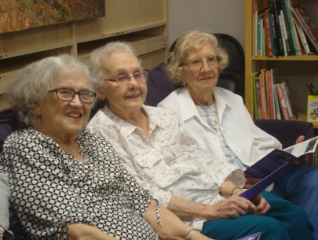  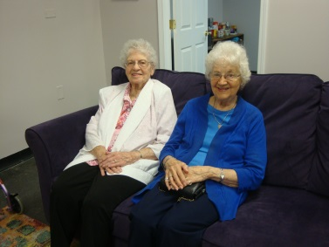 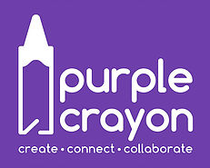

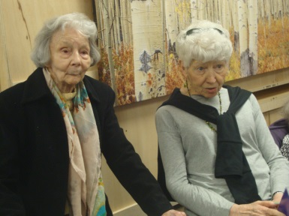

**Families and Residents Fall Festival**

**C:\Program Files\Microsoft Office\MEDIA\CAGCAT10\j0305493.wmfC:\Program Files\Microsoft Office\MEDIA\CAGCAT10\j0305493.wmfC:\Program Files\Microsoft Office\MEDIA\CAGCAT10\j0305493.wmfC:\Program Files\Microsoft Office\MEDIA\CAGCAT10\j0305493.wmfC:\Program Files\Microsoft Office\MEDIA\CAGCAT10\j0305493.wmfC:\Program Files\Microsoft Office\MEDIA\CAGCAT10\j0305493.wmfC:\Program Files\Microsoft Office\MEDIA\CAGCAT10\j0305493.wmf**

Friday, October 12th

Afternoon with fun activities in Craft Room

and Living Room in Assisted Living.

**12:30-2:30- Craft Room/Living Room**

*Displays, live music, light refreshments, crafts and games for chances to

win “Baptist Bucks” for the resident’s auction. Relax and enjoy time spent with each other. Bingo for Baptist Bucks will be in the Living Room.

**2:30 Living Room**

*Residents have a chance to spend their “Baptist Bucks” at our auction with assistance from staff or family.

**3:00 Living Room**

Resident Auction

You Are Invited

*continued from front page… The Life of Mary Allen..*

continued from front page… The Life of Mary Allen..

Mary reflected on the good and bad times throughout her life. She stated, “My faith has helped me get through tough times.” She talked about the sadness of her son E.V. passing away at four months old. Three of her sons, Sammy, Charles and Lee, passed away in adulthood, and the loss of her husband was very difficult. After Vernie passed way, she was diagnosed with breast cancer and went through radiation treatment and surgery. Eight years ago, she was diagnosed with lymphoma. After three sessions of chemo, she has been in remission. She stated, “Just trusting and knowing that God is in charge is all I need. He has brought me through the hard times.” Mary is also grateful for the many blessings God has given to her throughout her life, specifically her family, church and friends. She looks for the positive in difficult situations and influences us with her optimism.

In addition to the knowledge of gardening, Mary is extremely talented in quilting and sewing. She learned to sew as a teenager and made clothes for herself and her children. She learned and was inspired to quilt from her mother-in-law. After Vernie passed away she supplemented her income by selling quilts and wall hangings to individuals and craft stores, but mainly gave them away to friends and family.

After living in Asheville terrace Apartments for twenty-seven years, Mary moved into the WNC Baptist Home in October 2017. She regularly attends chapel, music programs, trivia, and special events. She stated, “It was hard leaving my home at first, but it has really grown on me here. I don’t have worry about cooking, laundry and cleaning. I like living here because it’s a wonderful place to live.” In addition to group activities, Mary continues to quilt and sew in her room. She loves listening to gospel music and sermons on the radio and television. She also enjoys visits from her dedicated Trinity Baptist Church family. Mary believes in the philosophy, “never stop learning.” She is constantly reading a new book and even watches YouTube videos on quilting. Mary’s disposition is purely sweet and kind. Thank you Mary, for spreading your love of Christ, hard work ethic and positive outlook to others.

M. Brown – Activity Director



September

September 4 - Yoga with Ellen Morrissey

September 6 - WNC Baptist Home Memorial Service- Remembering those we served

September 8 - Service with Grace Covenant Presbyterian Church

September 13 - Movie Songs with Daniel Lee

September 21 - History with Dr. Dan Pierce

September 27 - Gospel Music with Jake and Melinda Lohr

October

October 2 -Yoga with Ellen Morrissey

October 4 - Folk Songs with Daniel Lee

October 8 - October Birthday Party with Billy Woody

October 12 - Residents and Families Fall Festival

October 26 - History with Dr. Dan Pierce

October 30 - Music with The Joyful Mountaineers from New Bridge Baptist Church



***What’s in this issue…***

*She hopes she has influenced her children to be strong Christians. After Vernie passed away,*

* **Independence Day**
* **Summer of Fun**
* **Fall Festival**
* **Upcoming Events**
* **Chaplain’s Corner**

*she became a member of Trinity Baptist Church on October 25, 1984. She enjoyed singing*

*alto in the choir in the past and continues to love being a part of a friendly and supportive*

*congregation. When asked what being a Christian means to her, Mary responded with tears*

***Fall Is in the Air***

*in her eyes, “It means every-thing. It is the* ***only*** *thing that is important! Jesus means the*

*difference of where we spend eternity.” Mary hopes that the youth of today stay closer to*

*the Lord by going to church.*

*Mary has had good and bad times. She stated, “My faith has helped me get*

*Through tough times.” She talked about her sons who passed away: E.V. at four*

**The Mountain Echo**

*Months. Her three sons: Sammy, Charles and Lee passed in adulthood and loss*

*of her husband. Mary has had breast cancer, radiation and surgery. Eight years*

*ago she was diagnosed with Lymphoma. After chemo she is now in remission.*

*She stated, “Just trusting and knowing that God is in charge is all I need. He has*

**********************

*A Message from the*

*Administrator*

*\*\*\*\*\*\*\*\*\*\*\*\*\*\*\*\*\*\**

**Spotlight on Resident Mary Allen**

Mary Burvalee Anders (maiden name) was born in Asheville, NC, on July 16, 1924. She was the oldest of eight brothers and sisters. Her father, William Orville Anders, was a sharecrop farmer. Her mother, Jennie Teresa Wallen Anders, was a homemaker and helped on the farm. The family lived in many places throughout Buncombe county, they farmed tobacco as their primary cash crop. Mary and her siblings helped work and maintain the farms. Mary also assisted in rearing her siblings. Mary recalled taking care of her infant brothers and sisters so her mother could help work in the fields. Mary recalled, “I never remember thinking it was hard work. I didn’t dread it. It was just a way of life.” Her family moved at least every two or three years working in Leicester, Flat Creek and eventually settling in Barnardsville, NC

The relocation of the family and work responsibilities made it difficult for Mary to consistently stay in school. Mary’s mother worked for the Works Progress Administration during the depression era. During this time, Mary was unable to go to school for two years because she was needed to help take care of her family. She had a passion for reading and learning and frequently read books on many subjects.

Mary met her husband Vernie after her family moved to Barnardsville. He was a farmer growing the same crops as Mary’s family. Vernie and Mary married when she was seventeen. They had nine children, six boys and three girls, named Edgar, Carolyn, Elmer Vernie Jr. or “E.V.”, Sammy, Charles, Debbie, Gary, Lee, and Sheila. In addition to her family and farm work, Mary enjoyed raising big gardens, canning and later freezing vegetables. The last fifteen years before retirement, Vernie and Mary started their own greenhouse company called E.V. Allen and Sons. She learned how to grow many different flowers including poinsettias, Easter Lilies and mums, all from self-study books. Mary stated, “I loved working. I absorbed everything I could read on what I wanted to grow. I couldn’t have done it without God’s help.” She grew the flowers and Vernie delivered them to local florists in and around Asheville. After Vernie retired, they moved to Asheville in the early 1980s. Sadly, Vernie had a massive stroke and passed away in 1984.

Mary’s faith has been a steadfast rock through her life. Mary devotedly took her children to Barnardsville Baptist Church as often as possible. She laughed and stated, “It was a job getting that many children dressed and ready to go to church.” She hopes she

has influenced her children to be strong Christians. After Vernie passed away, she became a member of Trinity Baptist Church on October 25, 1984. She enjoyed singing alto in the choir in the past and continues to love being part of a friendly and supportive congregation. When asked what being a Christian means to her, Mary responded with tears in her eyes, “It means everything. It is the only thing that is important. Jesus means the difference of where we spend eternity.” Mary hopes the youth of today stay closer to the Lord by going to church.



*Brought me through the hard times.” Mary is grateful for her many blessings.*

*She is specifically grateful for her family, church and friends. Her positivity and*

*Optimism influences everyone.*

*Mary talents are quilting, sewing and her knowledge of gardening. She made her own*

***COME ONE,***

***COME ALL….***

***to the Western North Carolina Baptist Retirement Home’s 18th annual Fall Fest!***

***We will have games, food, fellowship, animals, and LIVE MUSIC!***

***The festivities will start at 12:30 p.m. in the Assisted Living section of the facility.***

***Friends and family members are welcome to come and enjoy a relaxing fun filled afternoon with their loved ones here at the home.***

***The festivities will end at 3:00 p.m. with the Residents’ Auction. The Baptist Bucks, which the residents have won during the day at the games, will be used for purchasing items at the Residents’ Auction.***

***God Bless!***

***Chris Elmer***

Visiting Hours

**8:00 a.m.**

**to**

**8:00 p.m.**

*clothes. She also made her children’s clothes. Her mother-in-law inspired her to*

*quilt. She was able to supplement her income by selling quilts and wall hangings.*

*She gave many quilts away to friends and family.*

*Mary lived in Asheville Terrace Apartments for twenty-seven years. She moved to*

*WNC Baptist Home in October 2017. She stated, “It was hard leaving my home at first, but*

*it has really grown on me here. I don’t have to worry about cooking, laundry or cleaning. I*

*like living here because it’s a wonderful place to live.”*

*Mary continue to sew, quilt, read a new book, watches YouTube videos on quilting, listens to*

*gospel music and sermons, visits with her dedicated Trinity Baptist Church family. Mary believes*

*in the philosophy, “never stop learning.” Her disposition is purely sweet and kind.*

*Thank you, Mary, for spreading your love of Christ and positive outlook on life to others.*

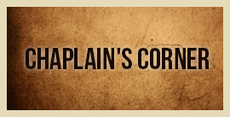

*From his book Rhymes with Reason, the late Herman Nodine, pastor, farmer, and author, writes a section “Having A Good Day,” which is a comment often exchanged between people.*

*Rev. Nodine says, “Having a good day is…Having a good conversation that flows two ways rather than one way. Having the awareness to see good things as they happen rather than hindsight to see them after they have passed by. Having enough frugality not to waste anything that someone else may use. Having enough strength not to exploit the weakness of someone less fortunate. Having enough honesty in my life to admit that I don’t always have to be right when I speak. Having enough thoughtfulness to be thankful for what you don’t have. Having enough wisdom to listen more than talk in the company of others. Having enough faith to believe the world will keep going long after we have departed.”*

*These insights will help us, if followed.*

*Have a good day as we move toward the fall season.*

* *Rev. Honeycutt*



Question?

Whom do you call when you have a computer issue, need assistance with a resident, or need generalized help?

Mason

Wagner

*If you say his name, this is most likely what you will hear: “Goes above & beyond.” “He is a smart guy.” “Has a good rapport with the residents.” “Always willing to help.” “Not only does he do his assigned jobs but also he is wonderful with the residents. Once he sat on the floor with a resident who had fallen and calmed her to allow staff to meet her needs.” “Great team player.” “Great sense of humor.” “He has a heart of gold and if we could look inside, that is exactly what we would see! He is an amazing young man!”*

*We are blessed to have him here at BRH.*

*M. Brown – Activity Director*

**Continue to the top on last page………**

*There is limited space for activities. Please call ahead to secure a spot, confirm location, and time,*

828-254-9675